RECRU_REGRESSION_SNAPSHOTS

|  |  |  |
| --- | --- | --- |
| DATE | TC_Name | TOTAL Screenshots |
| AUG – 25 – 2020 | TC-Recru_MyProcesses_E2E_AddNewCandidate_HRStage | 12 |
| AUG – 25 – 2020 | TC-Recru_MyProcesses_E2E_NewCandidate_BAstudio | 2 |
| AUG – 25 – 2020 | TC-Recru_MyProcesses_E2E_NewCandidate_People | 2 |
| AUG – 25 – 2020 | TC-Recru_MyProcesses_E2E_AddNewCandidate_TechnicalStage | 11 |
| AUG – 25 – 2020 | TC-Recru_MyProcesses_E2E_AddNewCandidate_ClientStage | 12 |
| AUG – 25 – 2020 | TC-Recru_MyProcesses_E2E_AddNewCandidate_PreOfferStage | 10 |
| AUG – 25 – 2020 | TC-Recru_MyProcesses_E2E_AddNewCandidate_OfferStage | 9 |

TC_Name: TC-Recru_MyProcesses_E2E_AddNewCandidate_HRStage

Screenshots:

1.

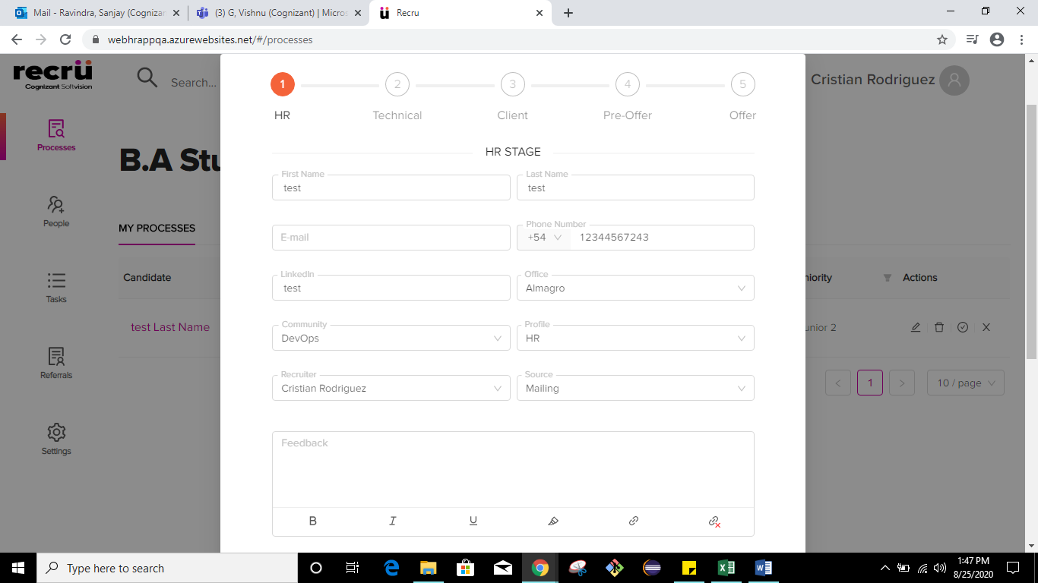

2.

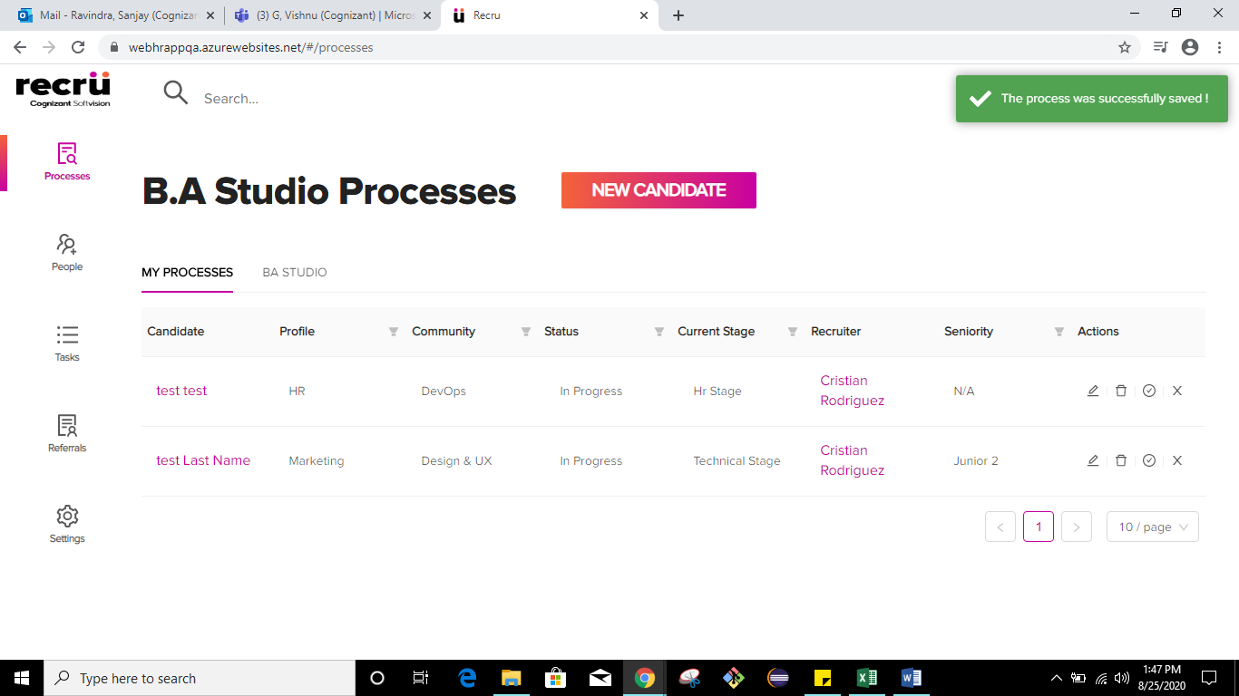

3.



4.



5.

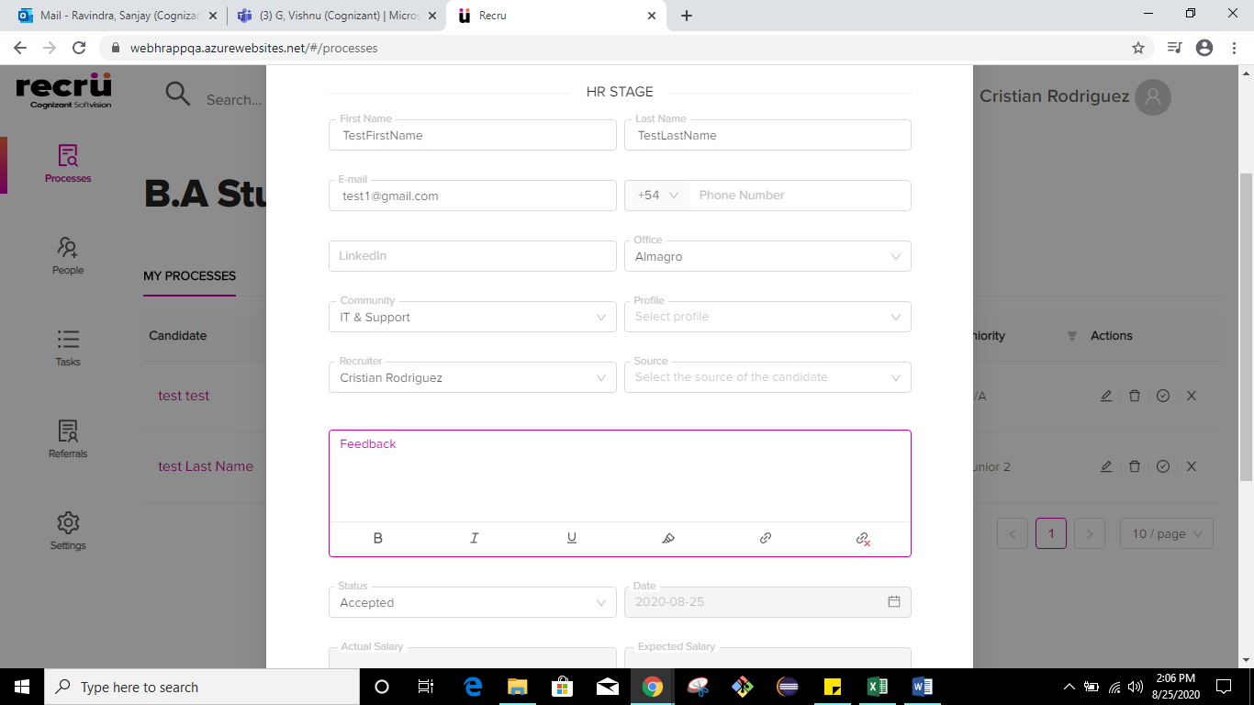

6.

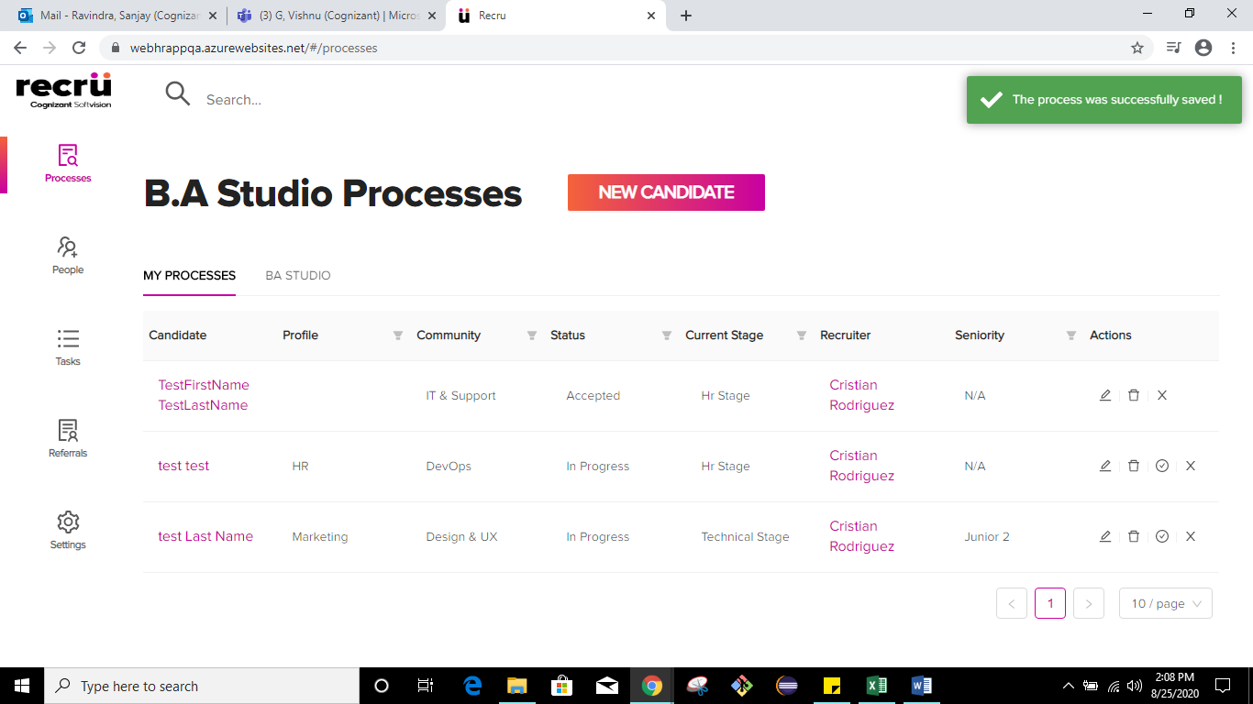

7.

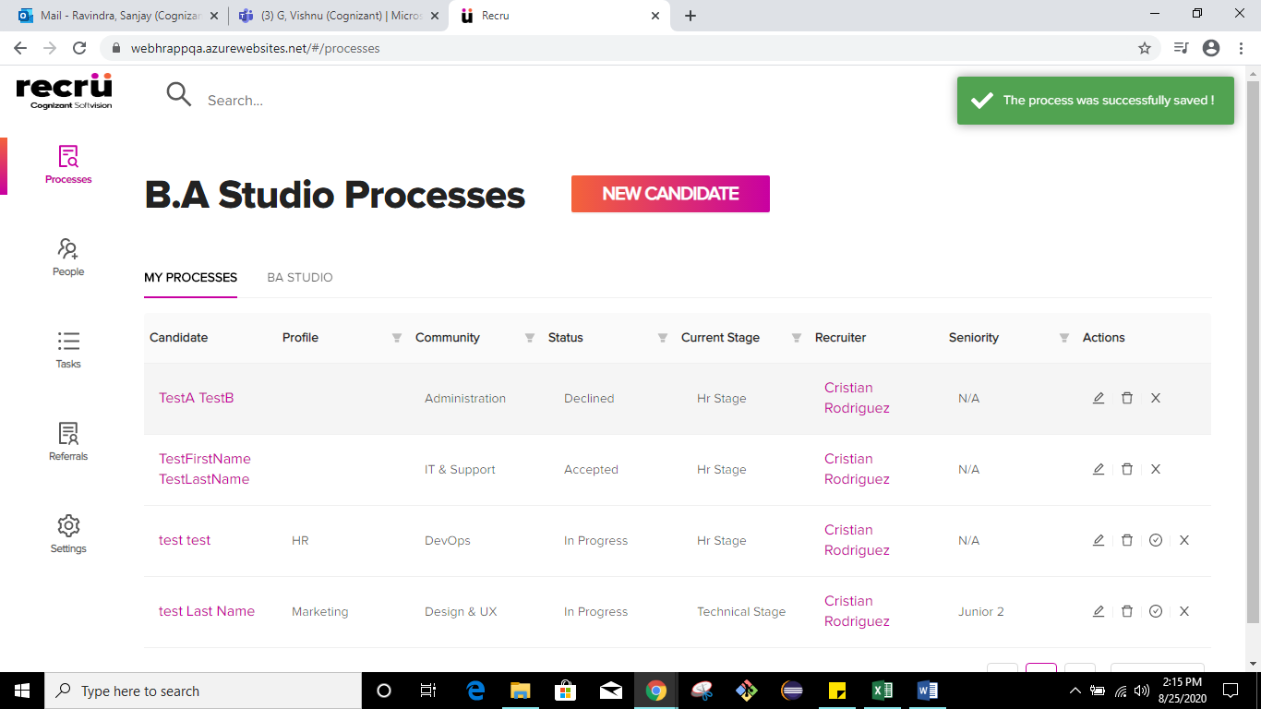

8.

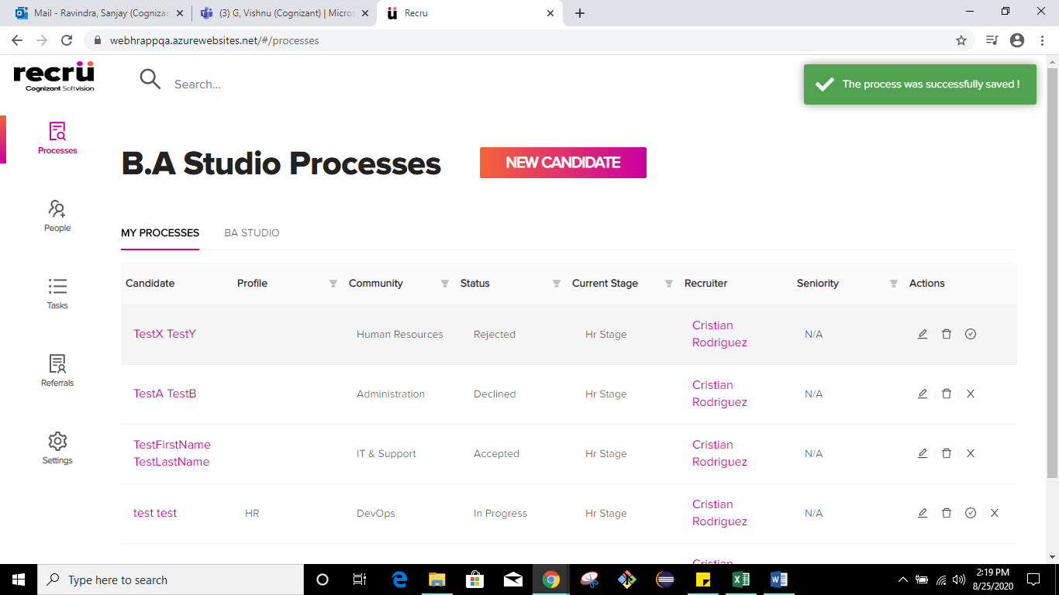

9.

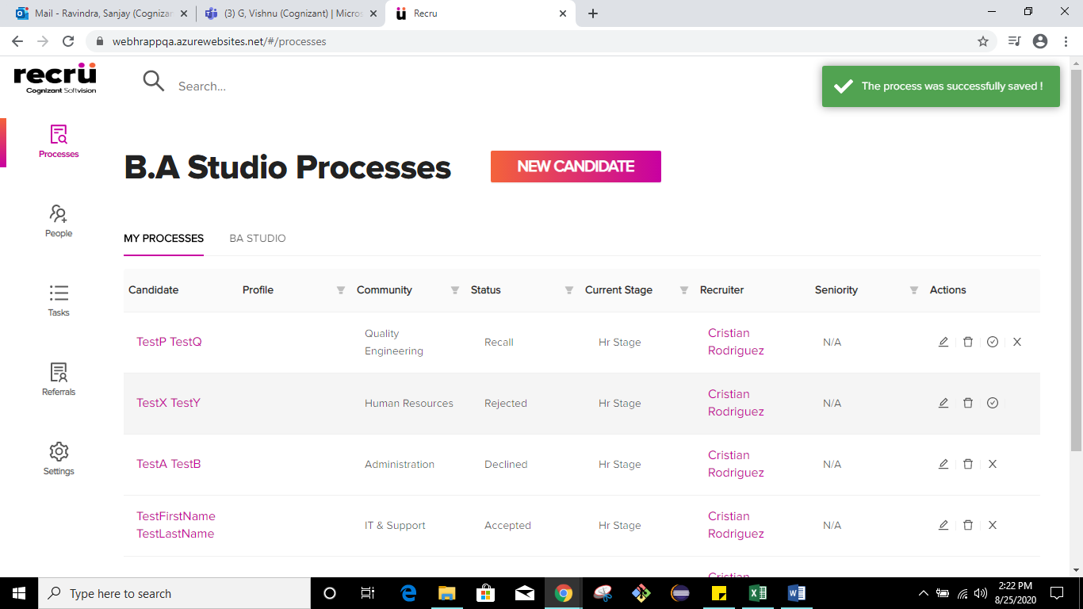

10.

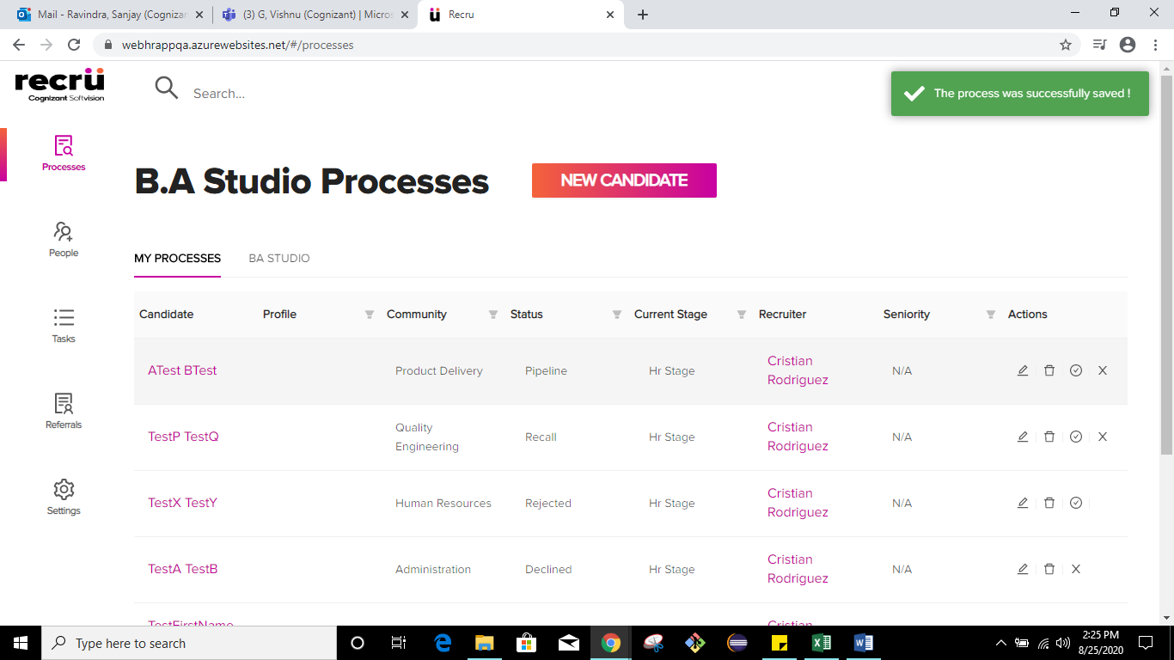

11.

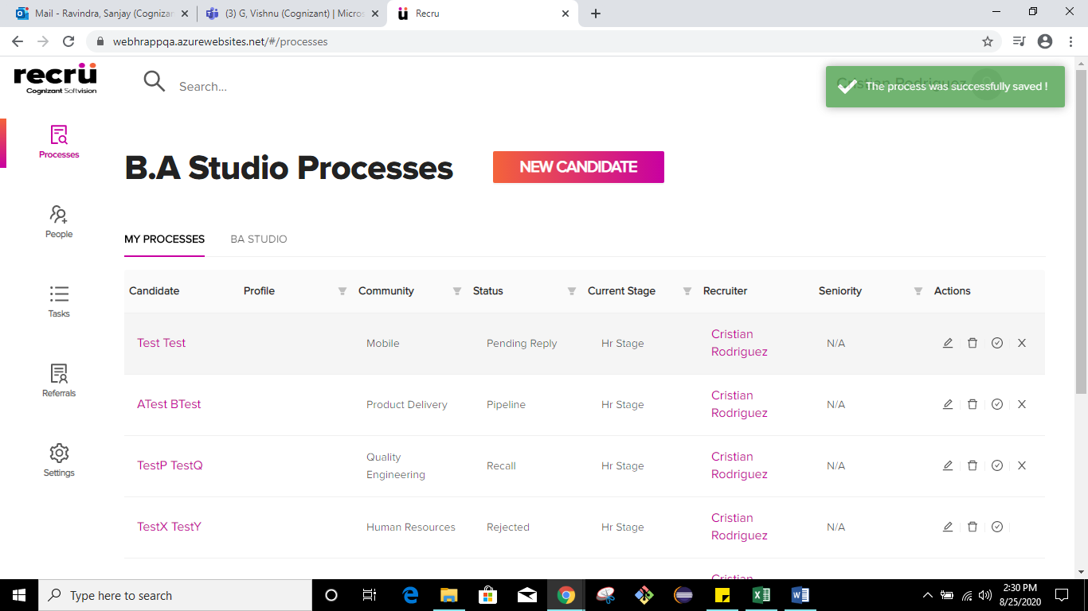

12.

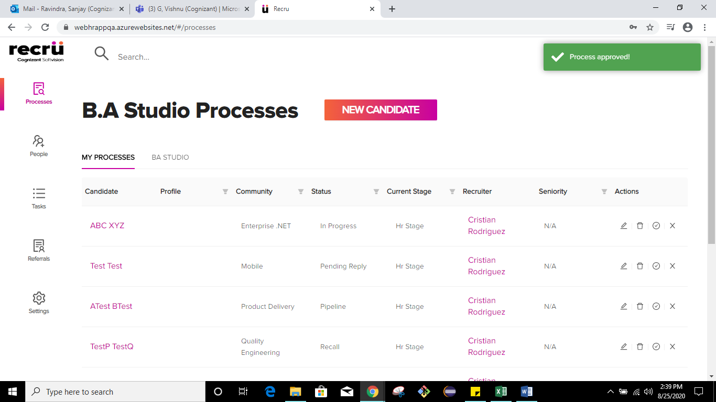

TC_Name: TC-Recru_MyProcesses_E2E_NewCandidate_BAstudio

Screenshots:

1.

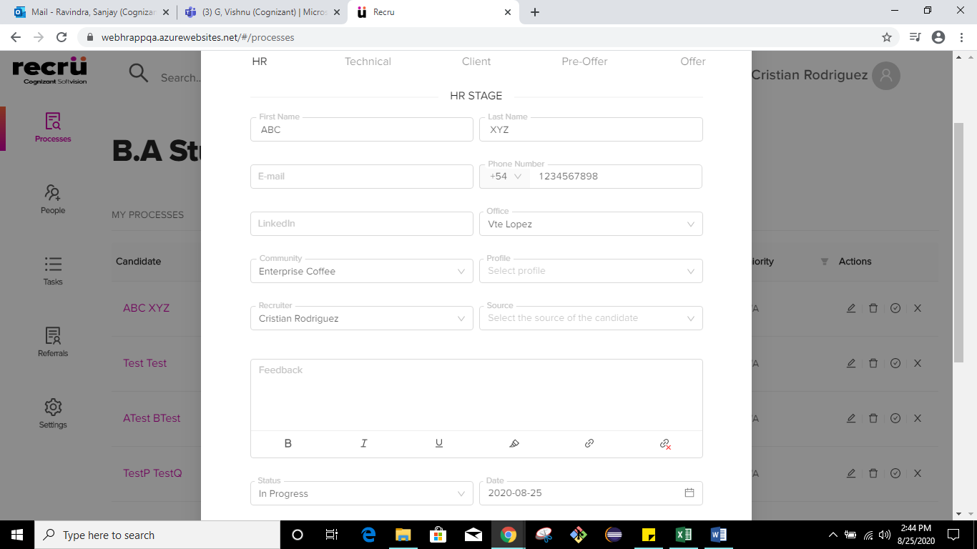

2.

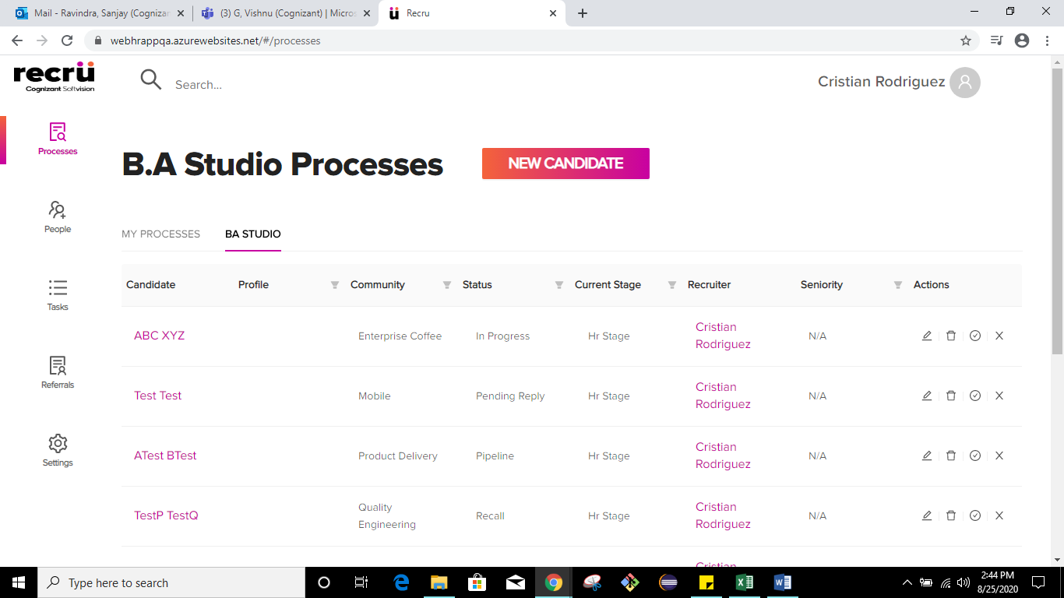

TC_Name: TC-Recru_MyProcesses_E2E_NewCandidate_People

Screenshots:

1.

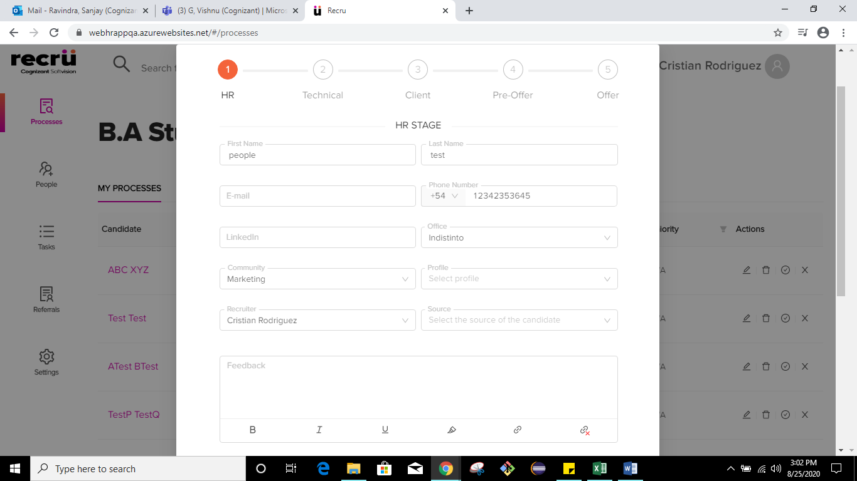

2.

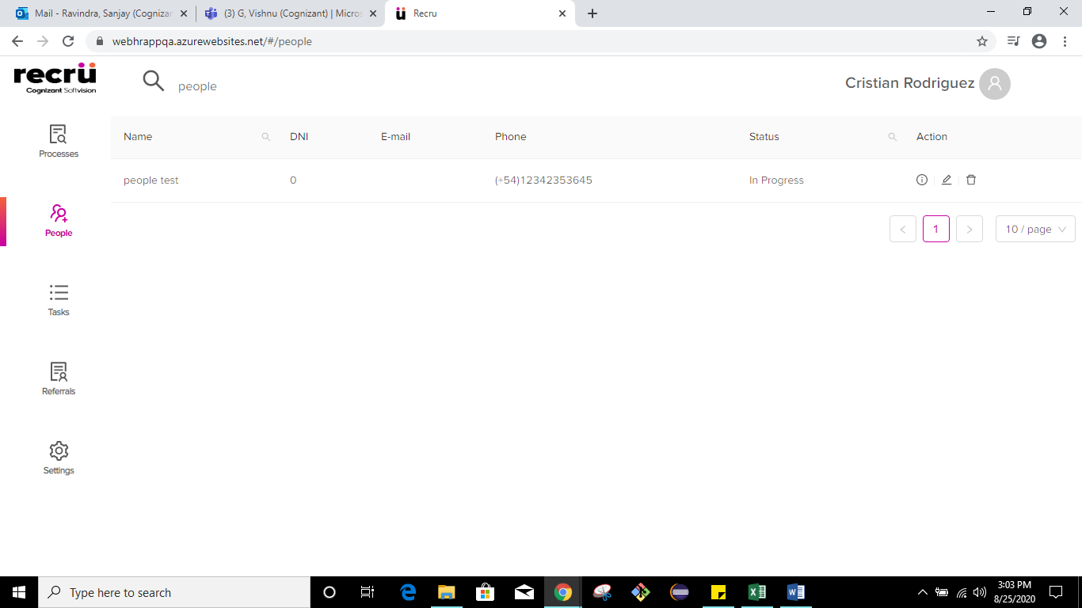

TC_Name: TC-Recru_MyProcesses_E2E_AddNewCandidate_TechnicalStage

Screenshots:

1.

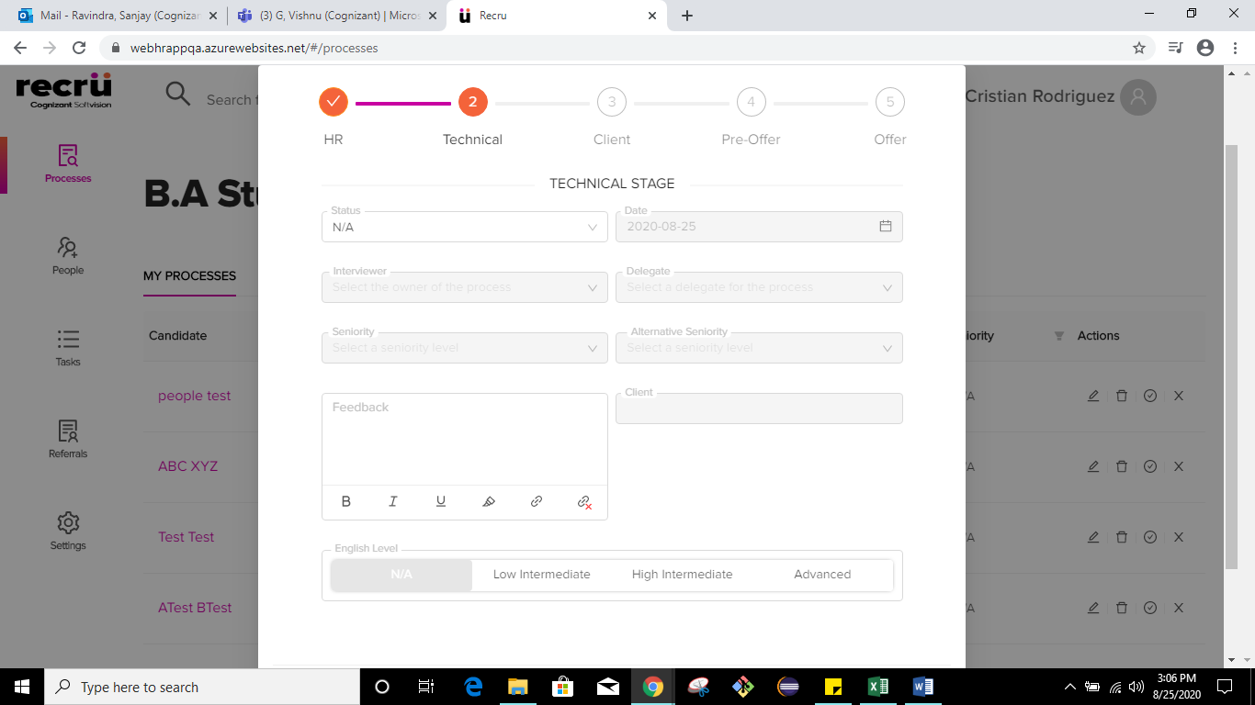

2.

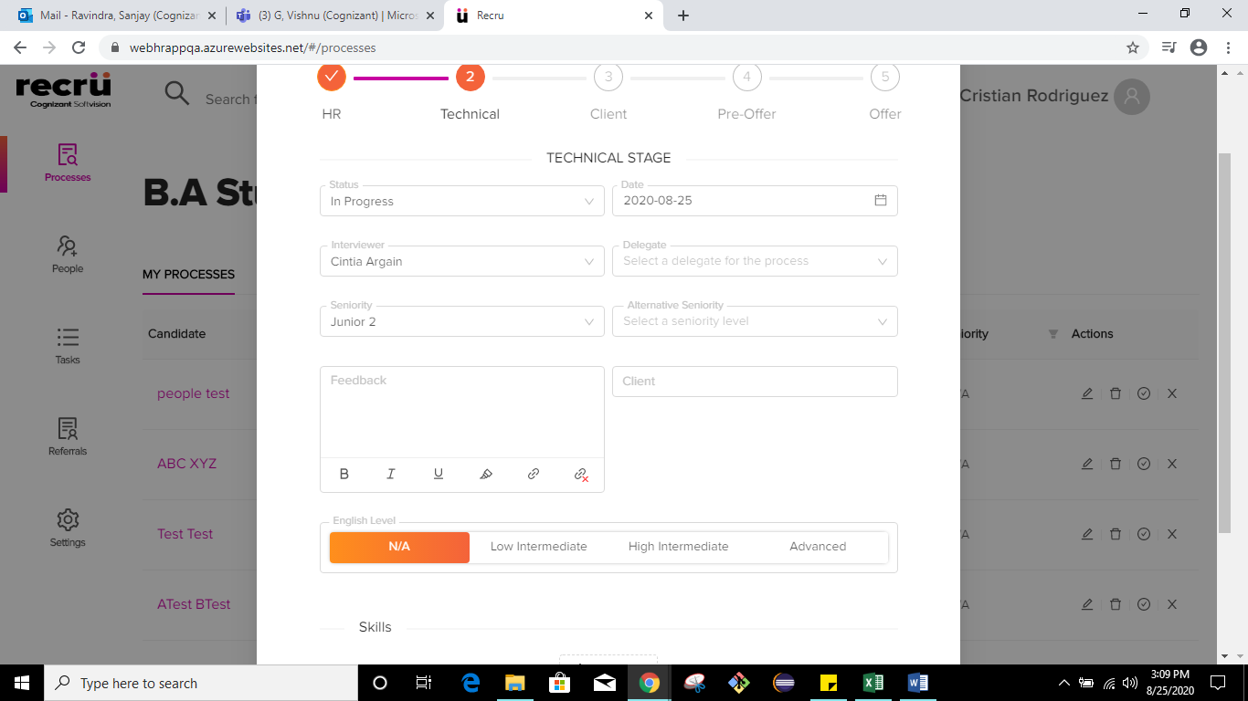

3.

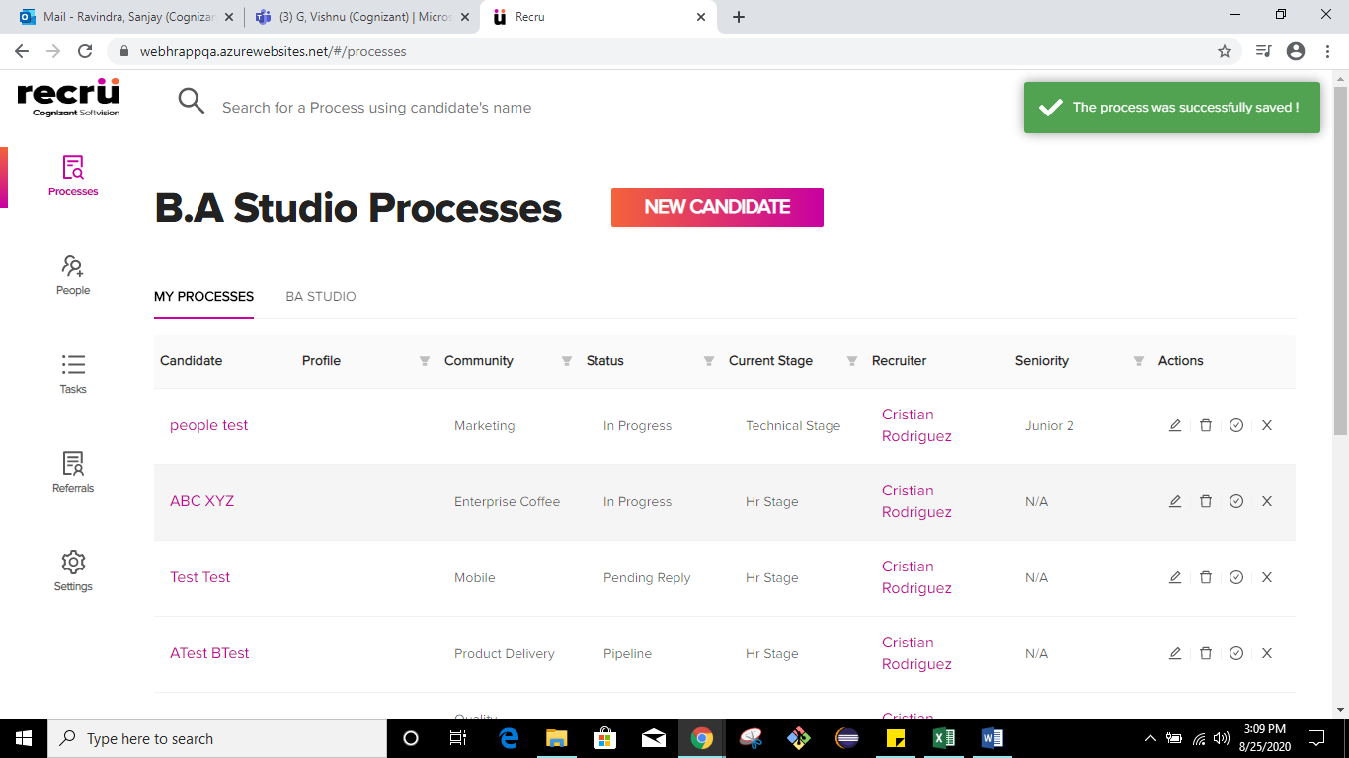

4.

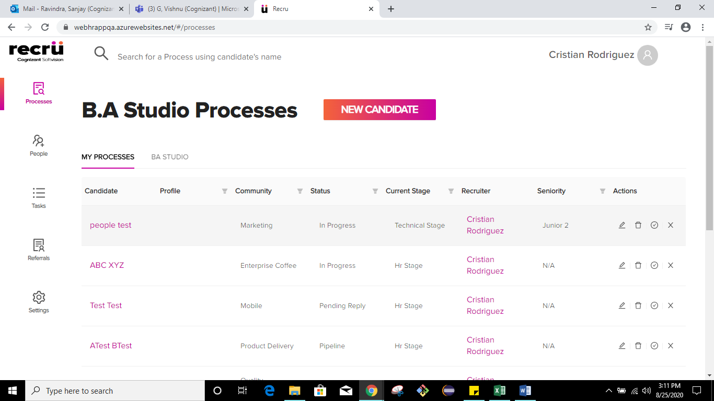

5.

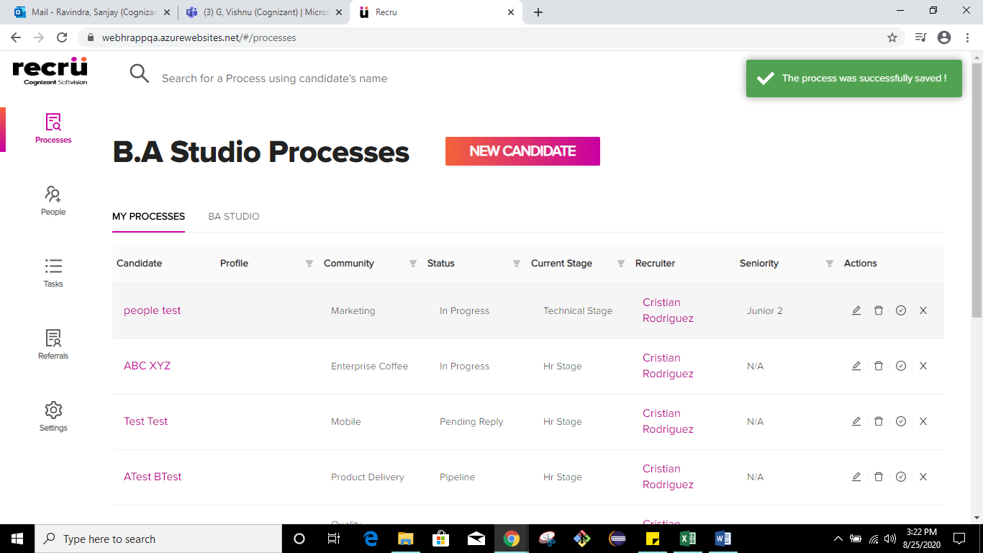

6.

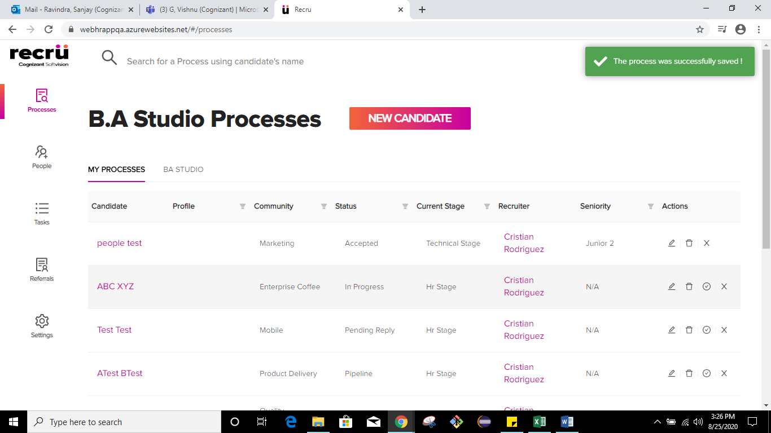

7.

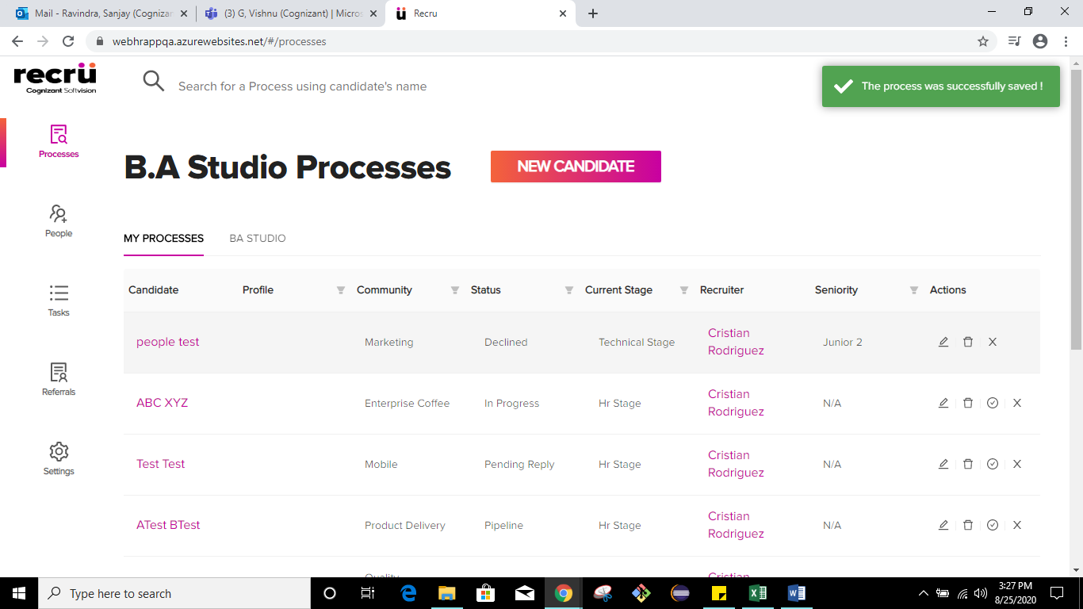

8.

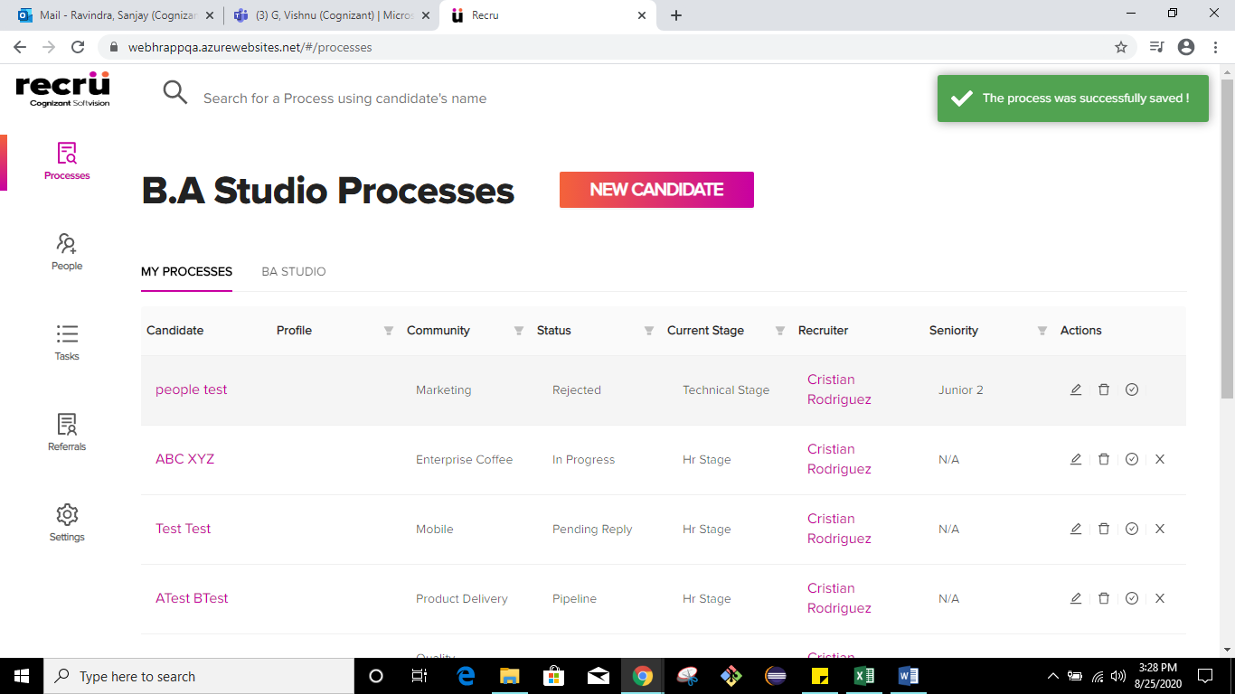

9.

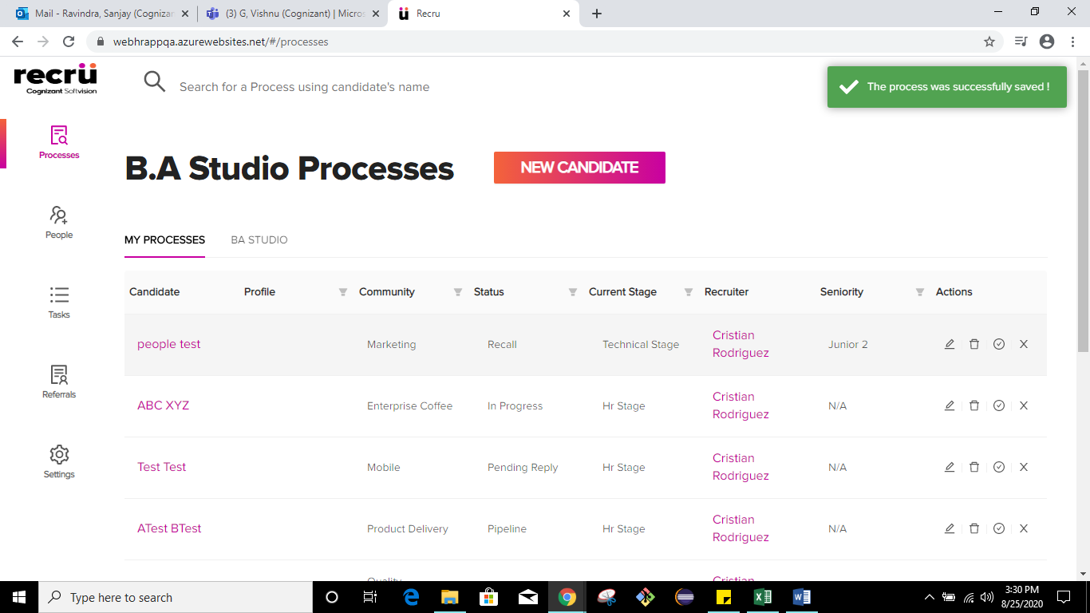

10.

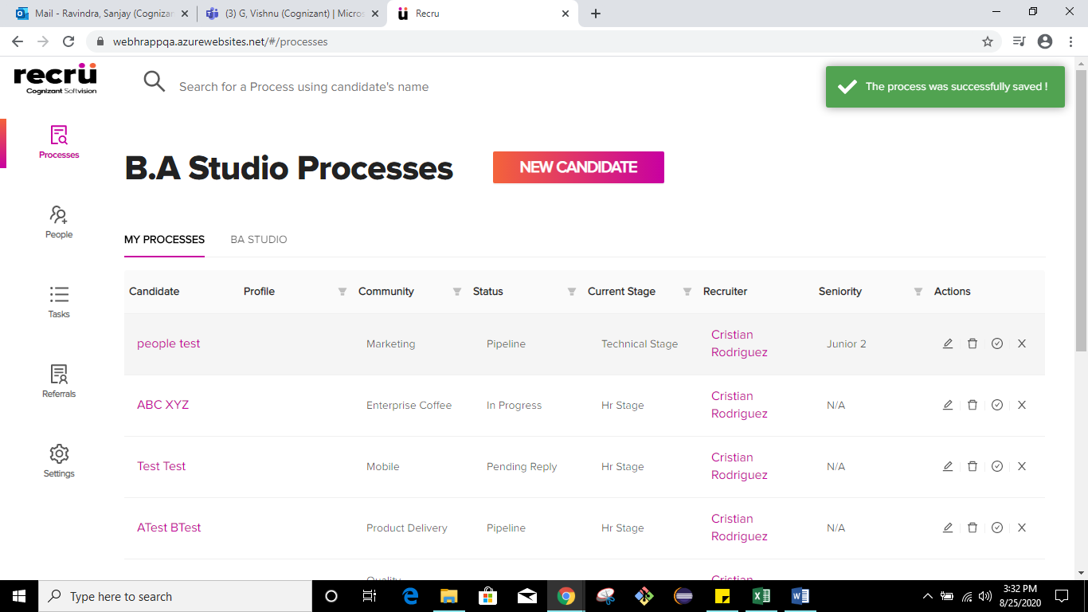

11.

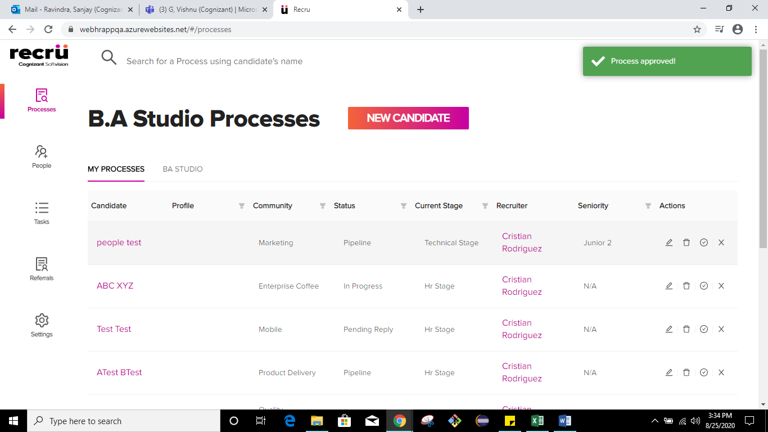

TC_Name: TC-Recru_MyProcesses_E2E_AddNewCandidate_ClientStage

Screenshots:

1.

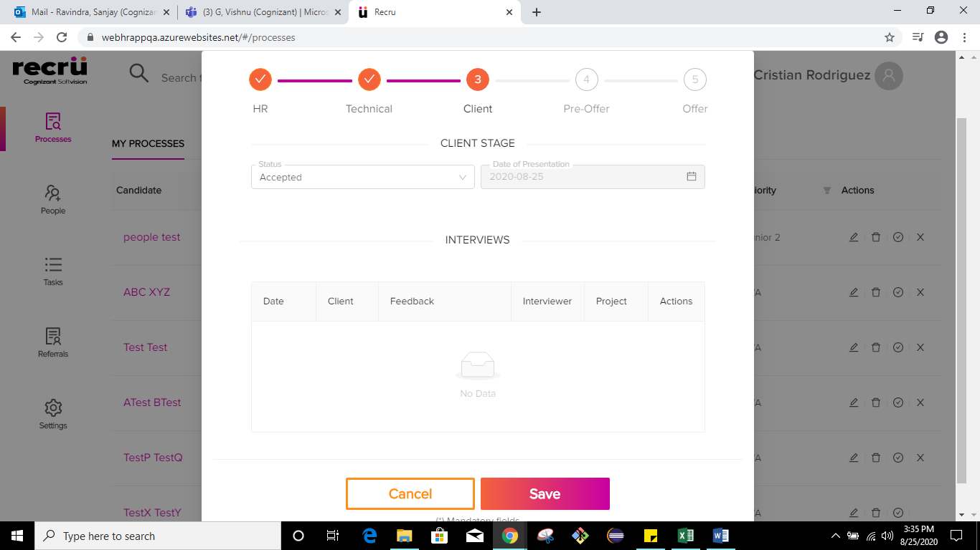

2.

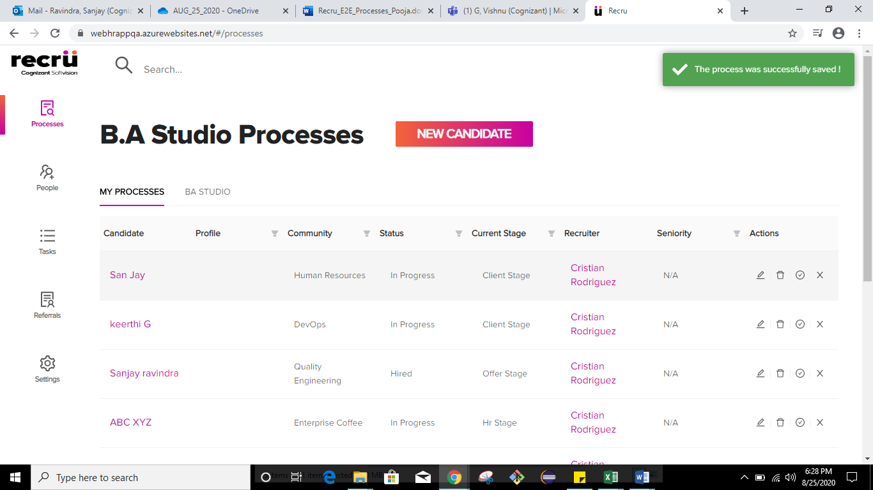

3.



4.

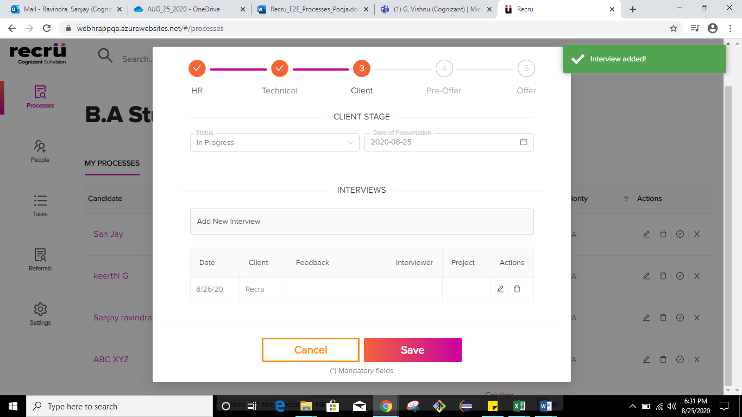

5.

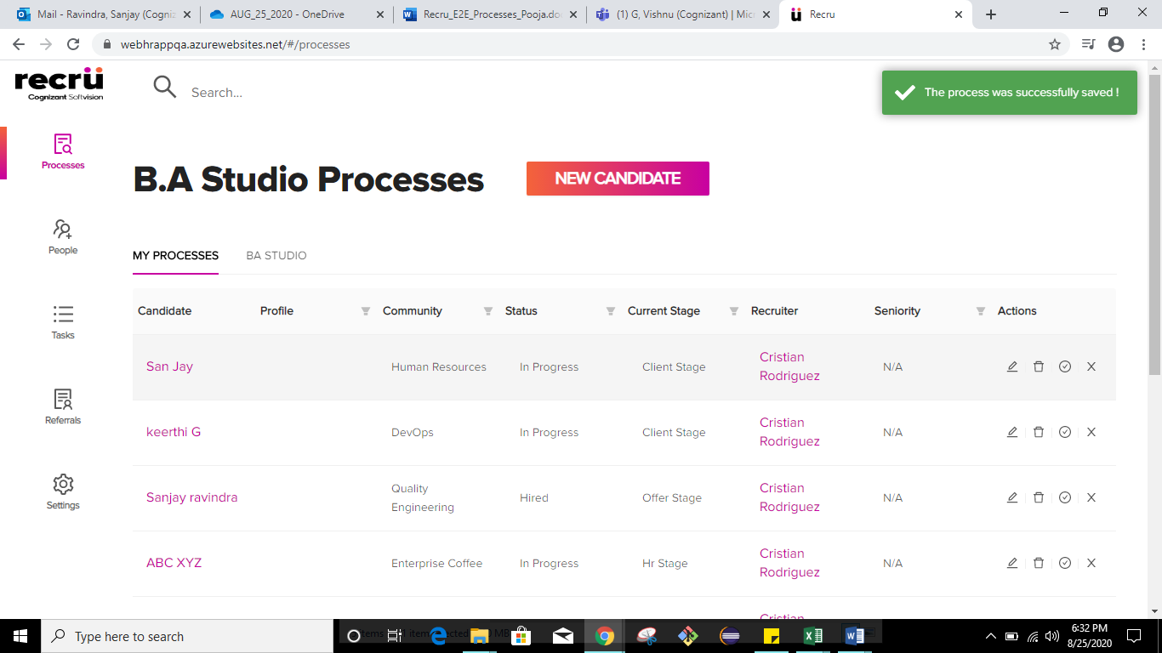

6.

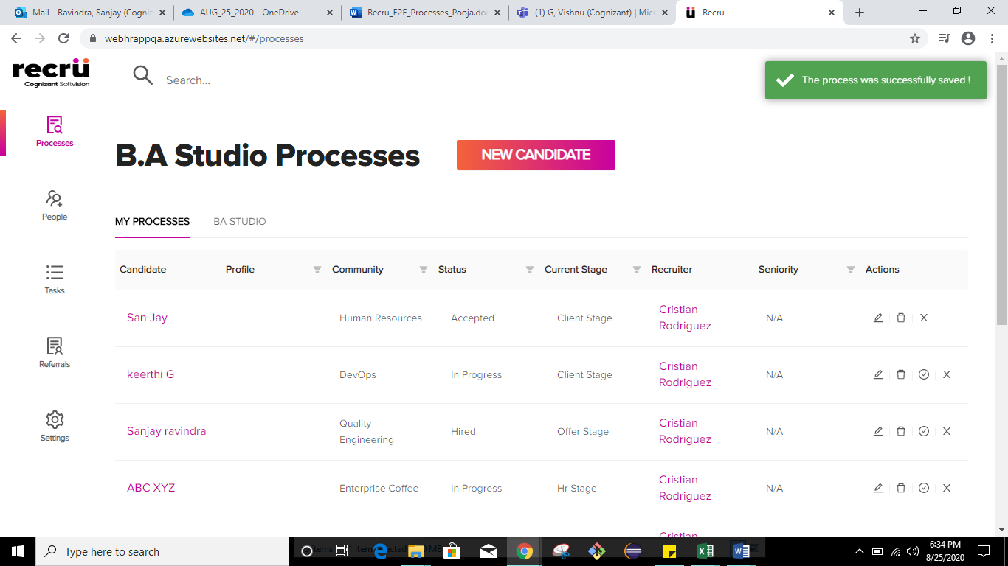

7.

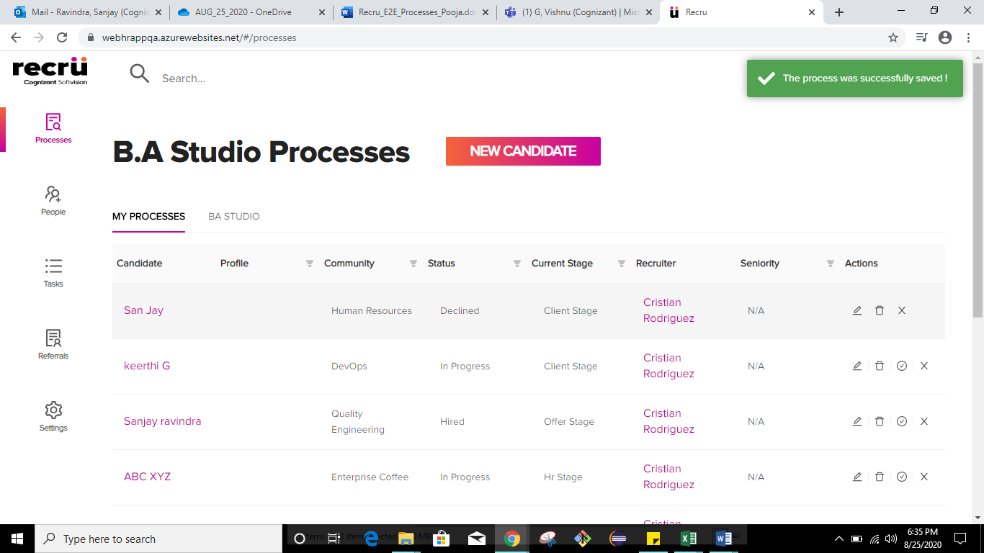

8.

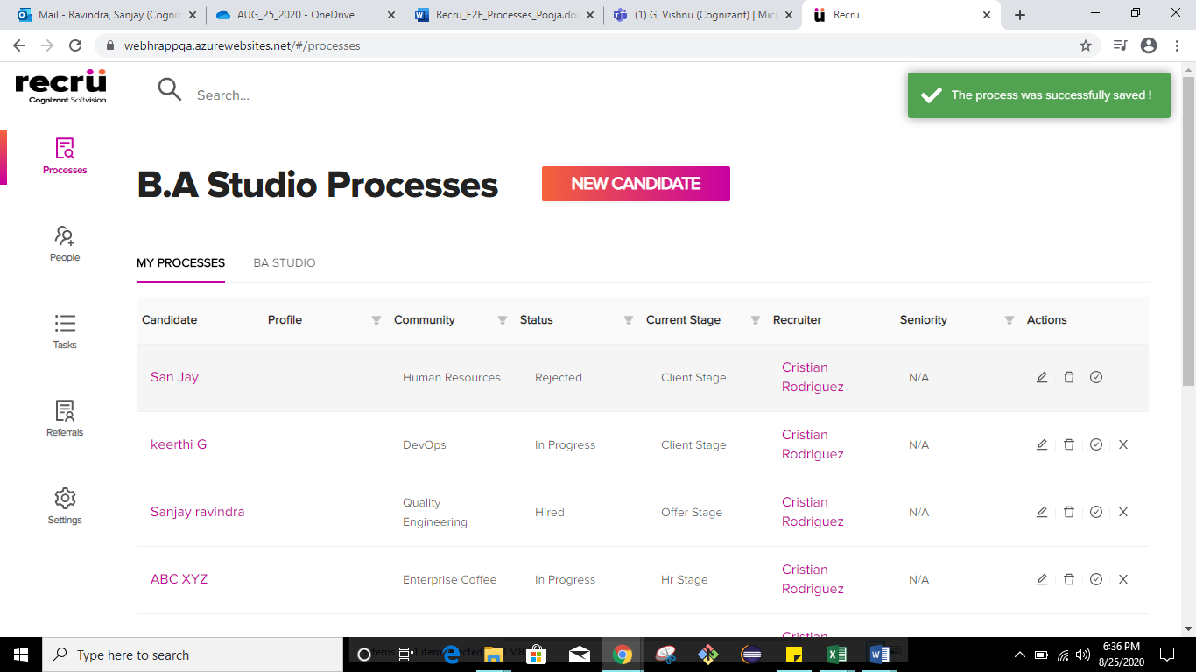

9.

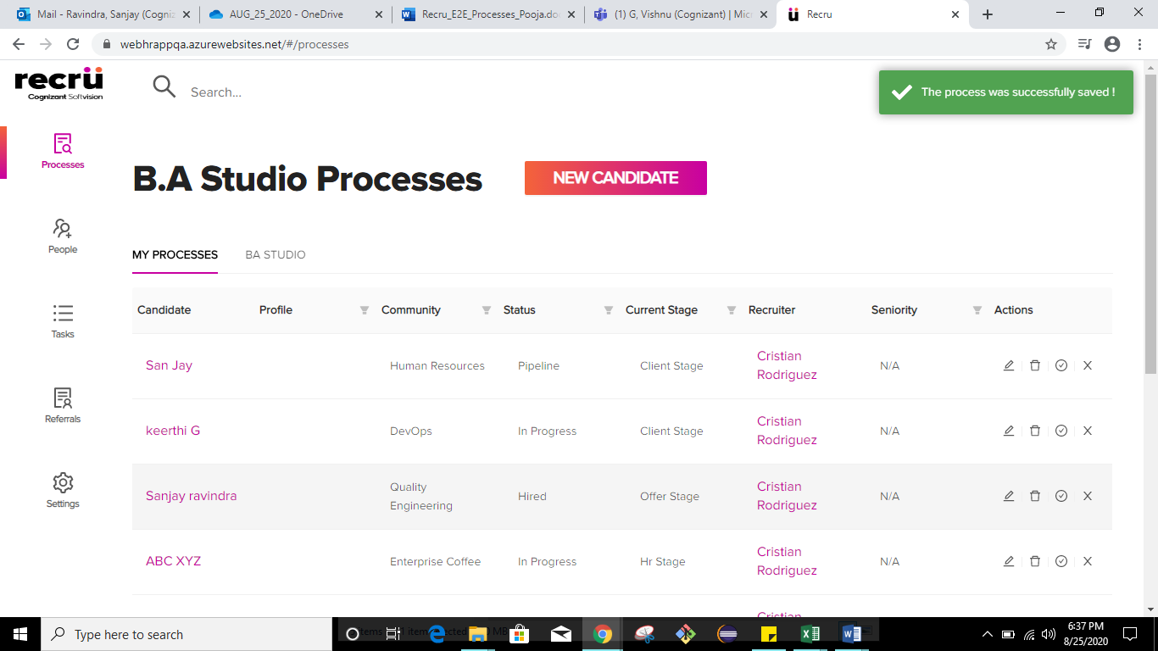

10.

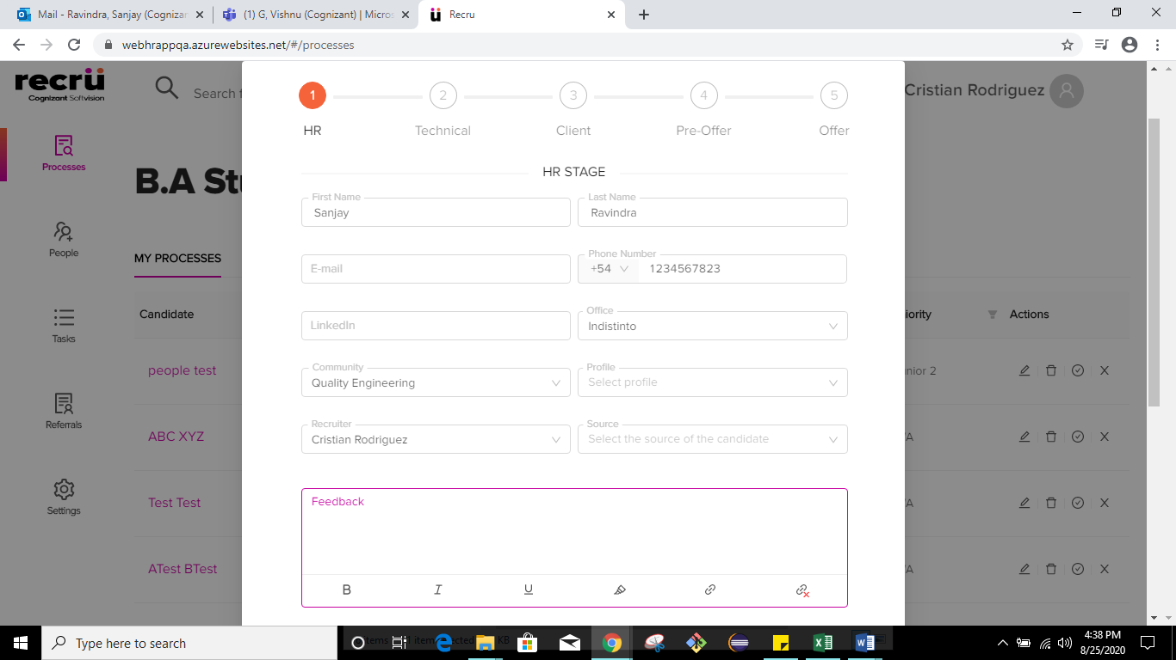

11.

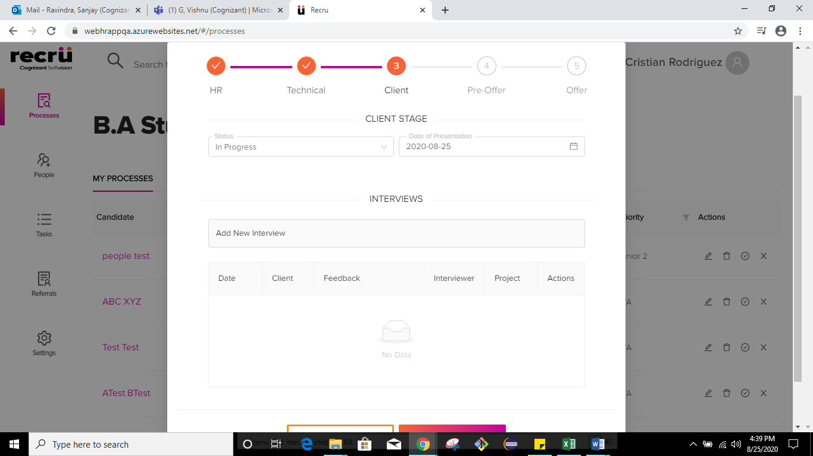

12.

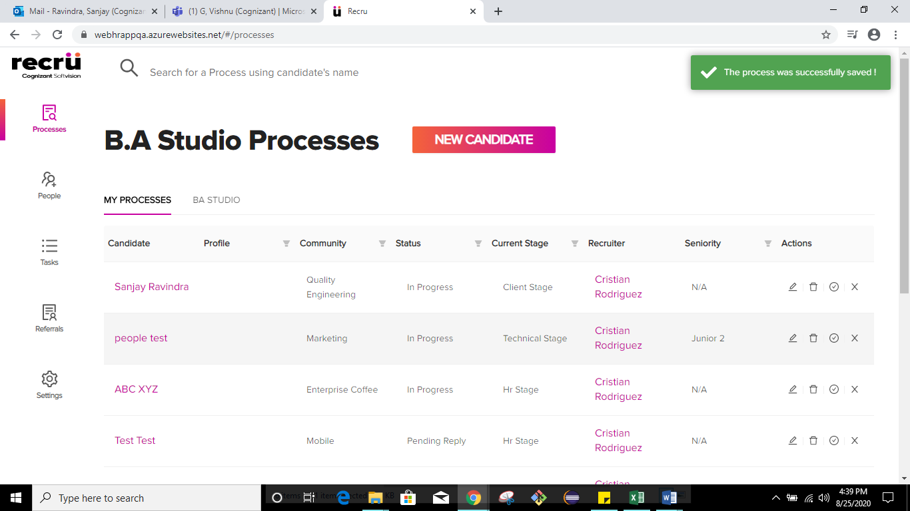

TC_Name: TC-Recru_MyProcesses_E2E_AddNewCandidate_PreOfferStage

Screenshots:

1.

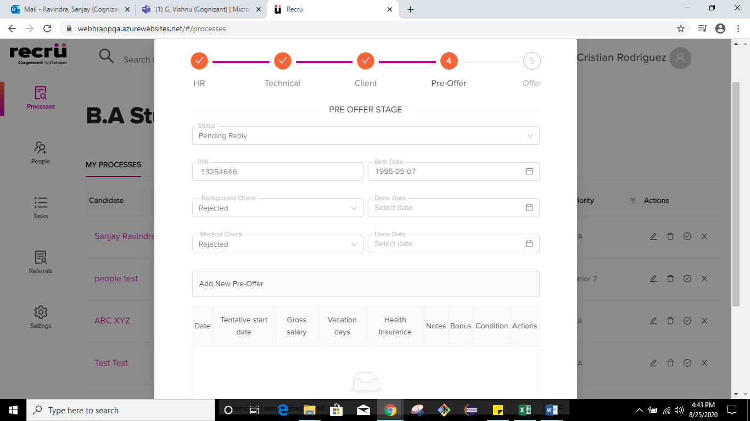

2.

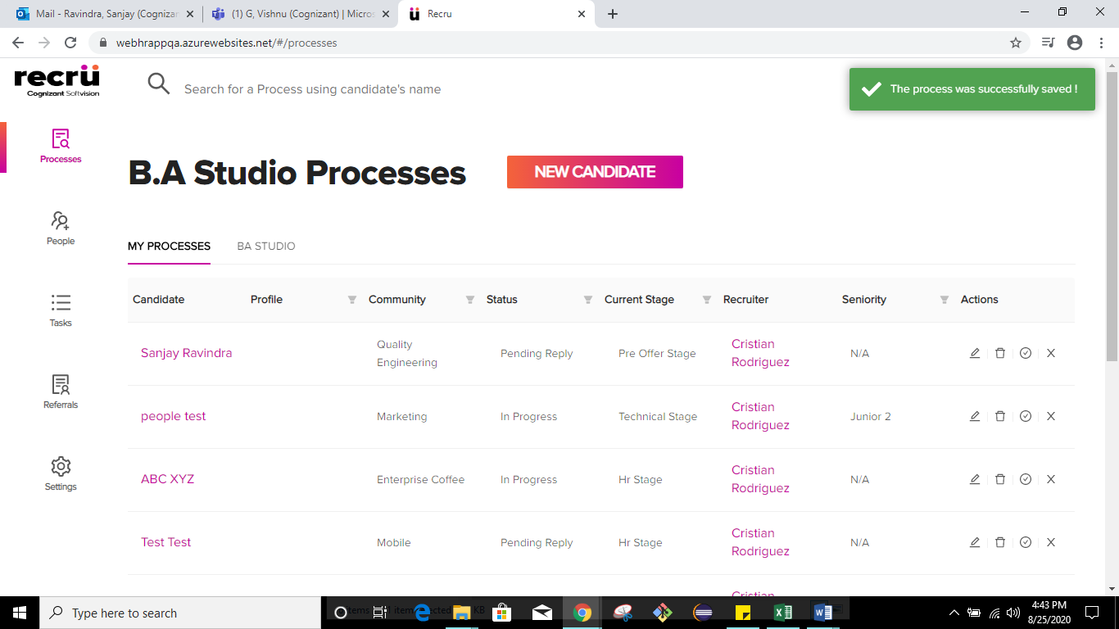

3.



4.

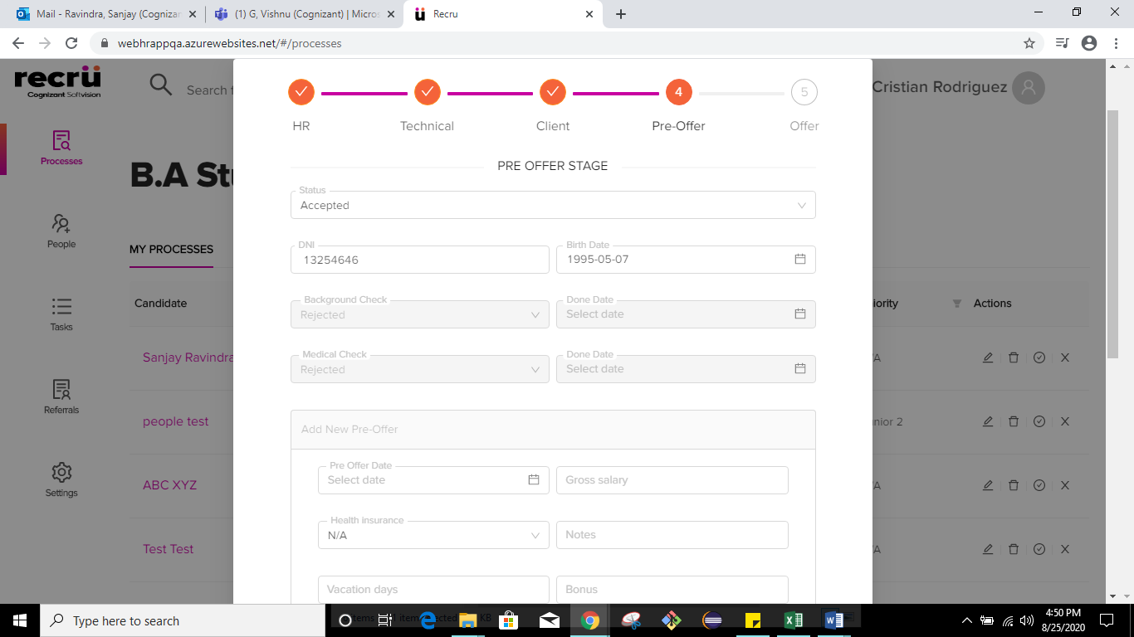

5.

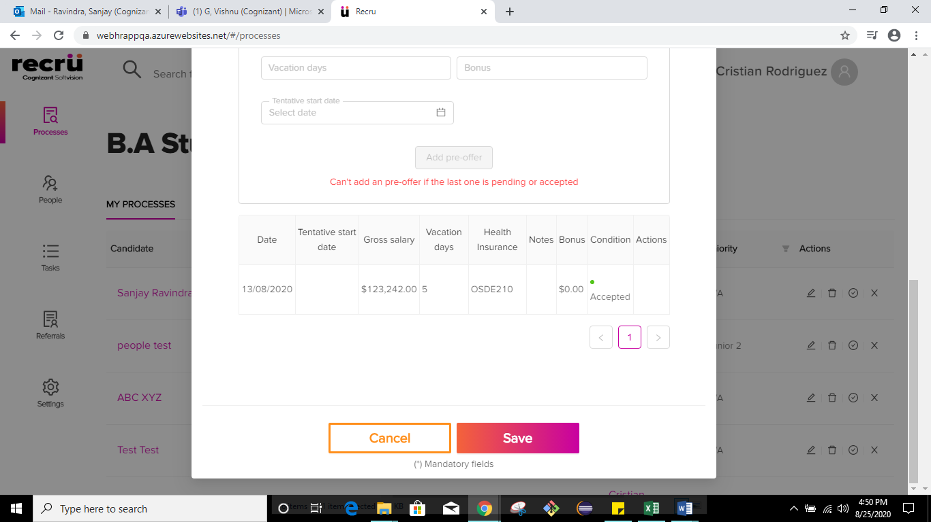

6.

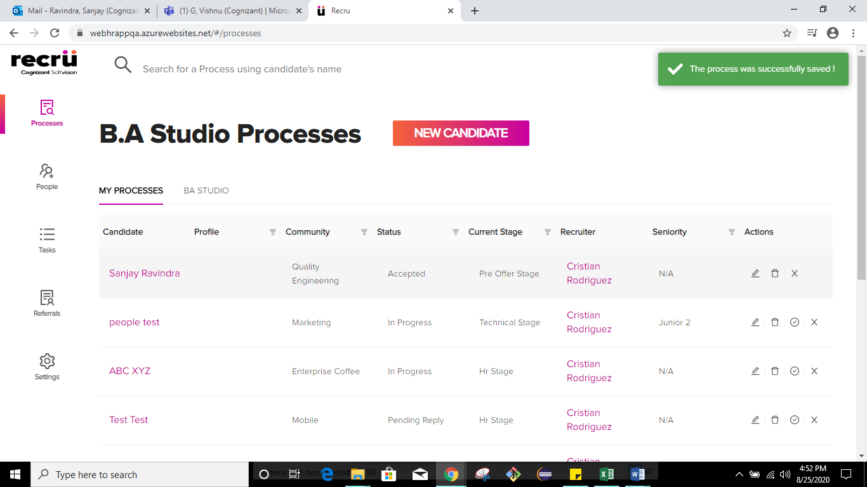

7.

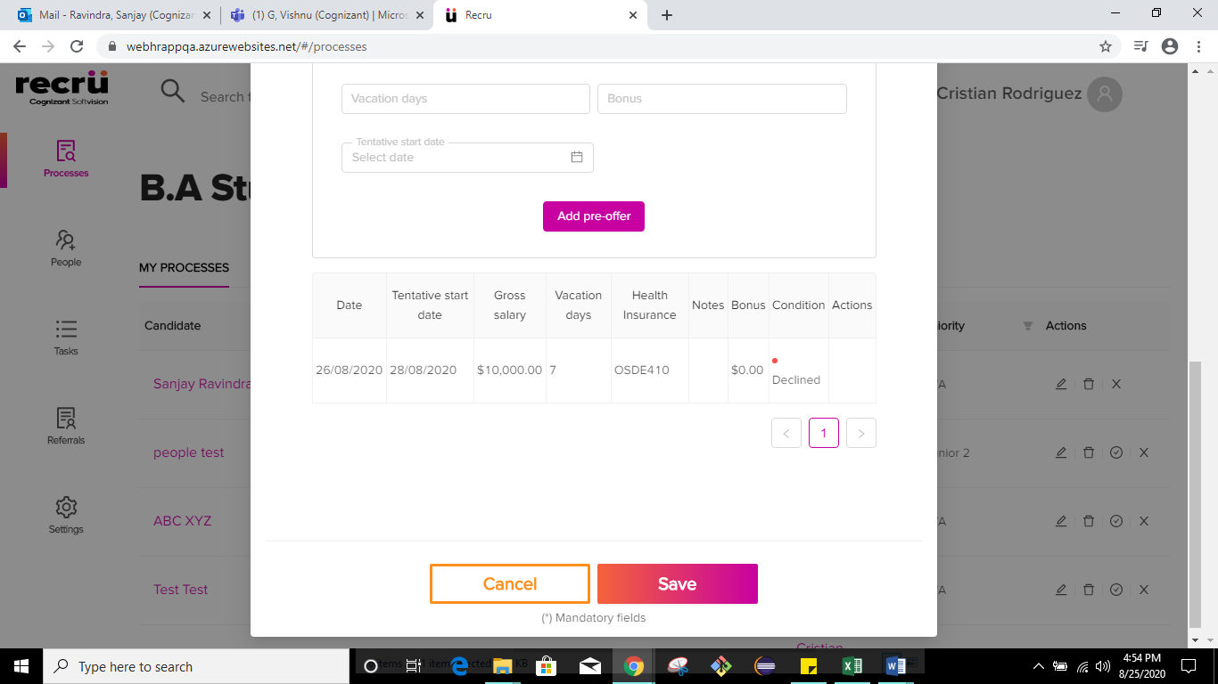

8.

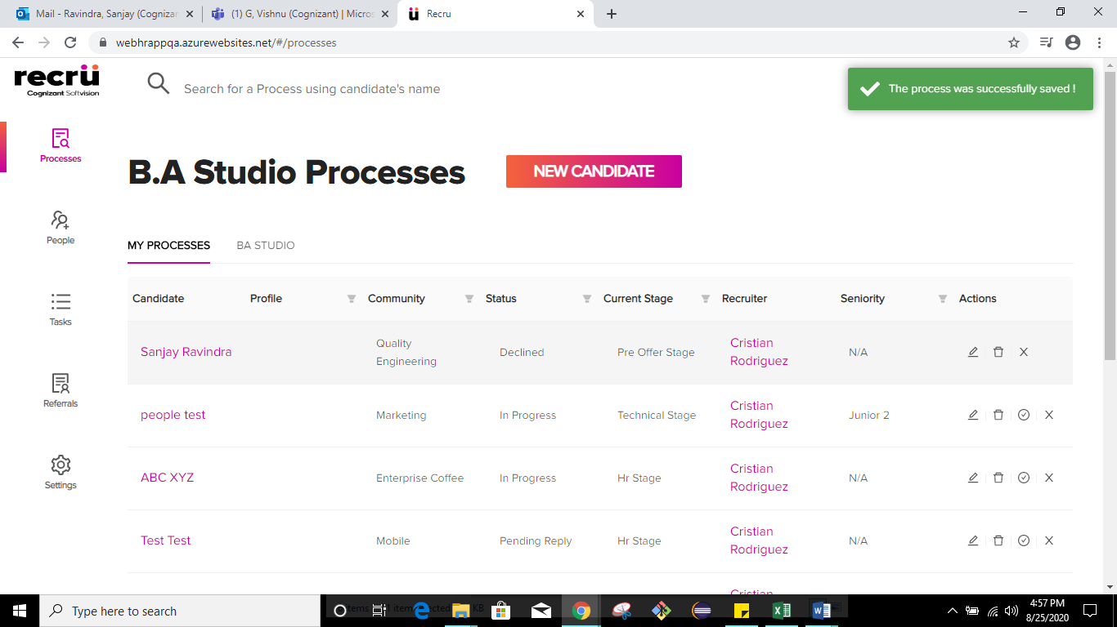

9.

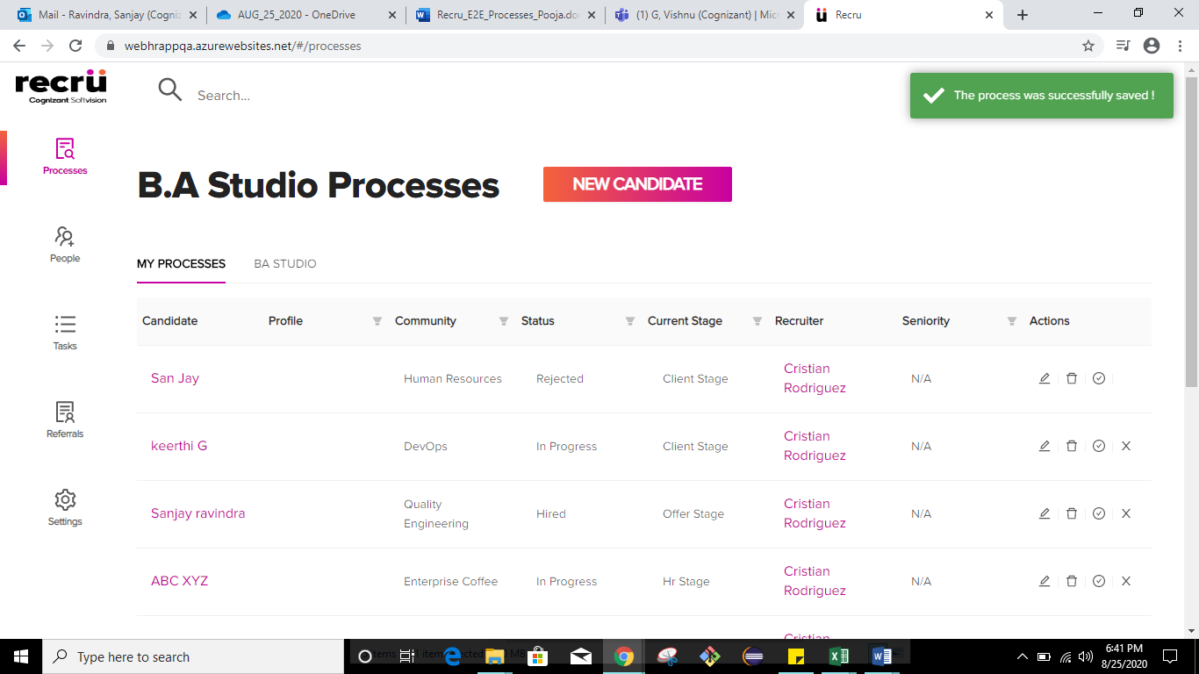

10.

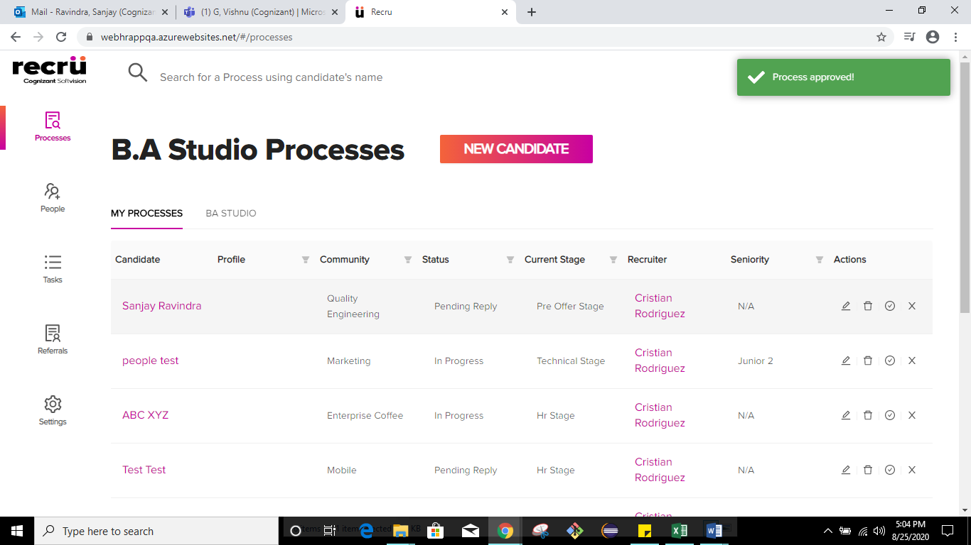

TC_Name: TC-Recru_MyProcesses_E2E_AddNewCandidate_OfferStage

Screenshots:

1.

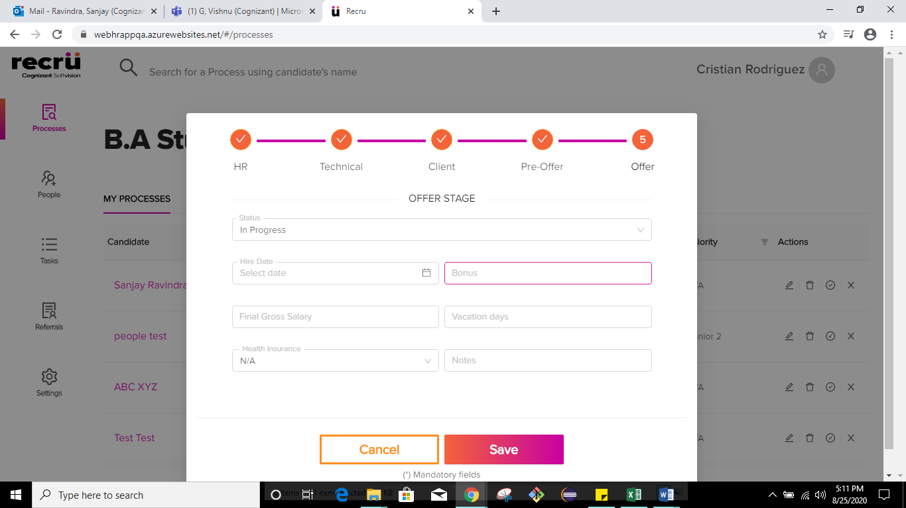

2.

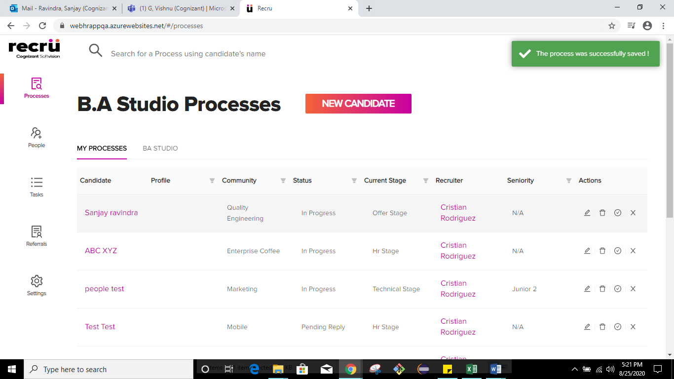

3.

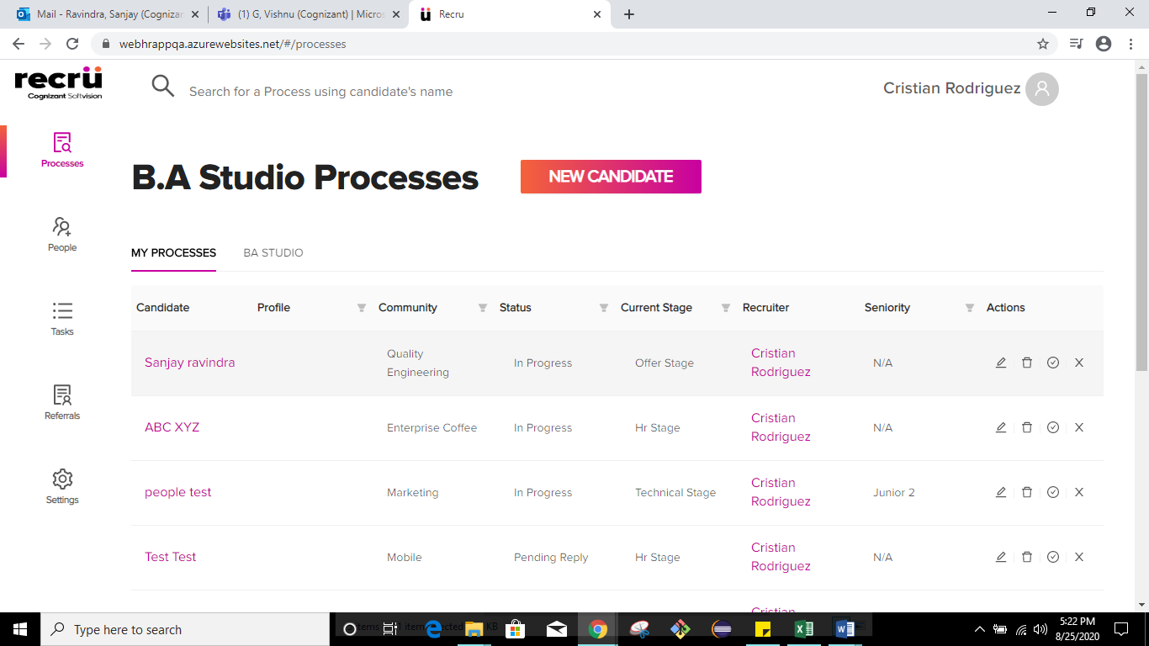

4.



5.

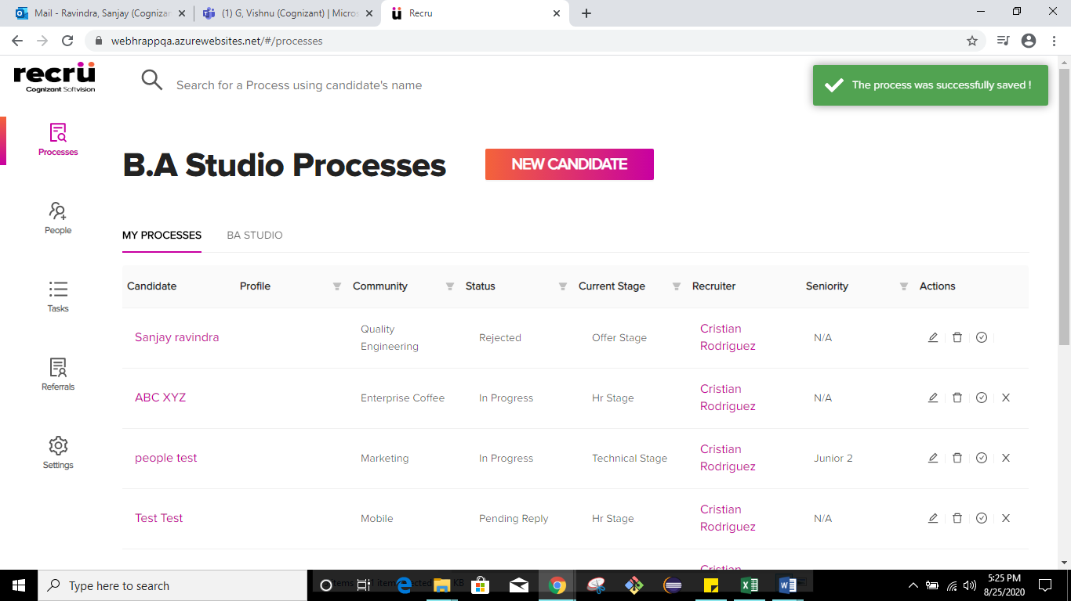

6.

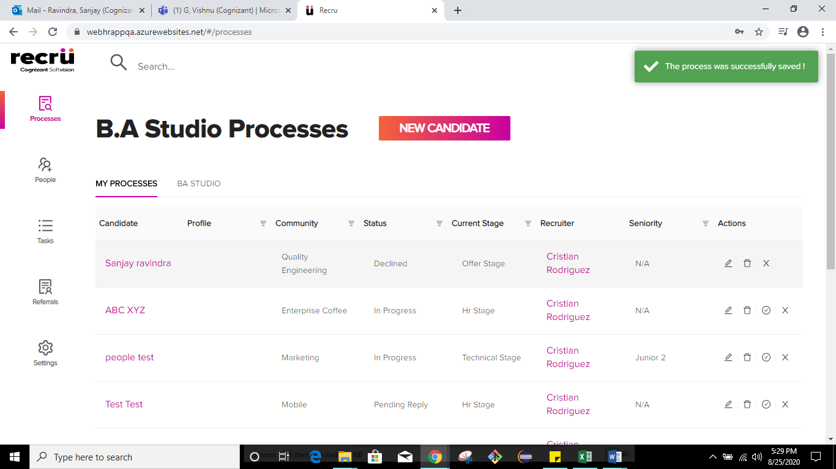

7. 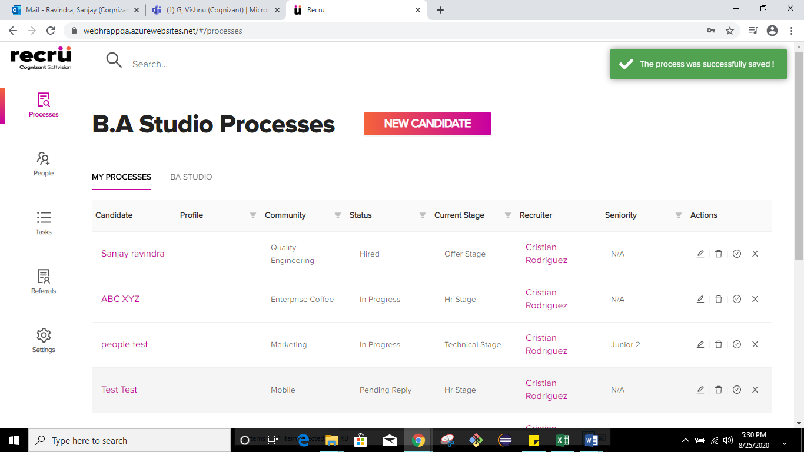

8.

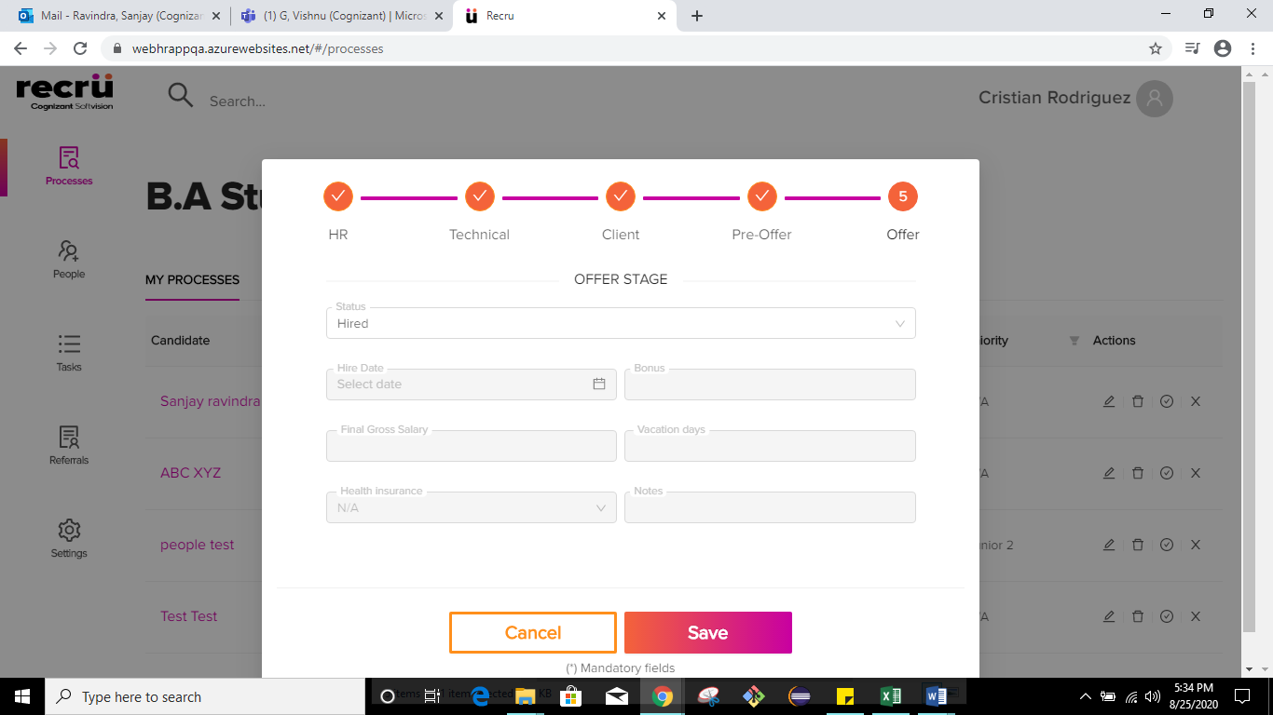

9.

